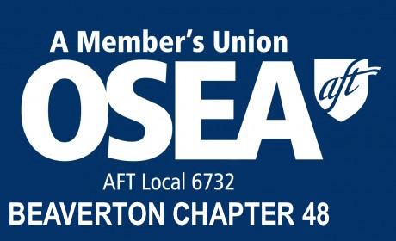

Bill of Rights

We, the thousands of working people who are members of the Oregon School Employees Association (OSEA), AFT Local 6732, proclaim these rights for ourselves and our fellow employees wherever they are employed and whatever their positions.

- The right to be treated with dignity and respect in our employment.
- The right to be paid a living wage and reasonable compensation for what we do.
- The right to conduct our private lives without interference.
- The right to participate in those decisions of our employers that affect our employment.
- The right to be free from unlawful discrimination.
- The right to join a labor organization and bargain collectively for our common interests without retaliation.
- The right to have our legitimate grievances redressed fairly and without delay.
- The right to safe and reasonable working conditions.
- The right to retire – not in poverty – but with pride and dignity.

For ourselves and our fellow employees, we pledge to each other and to our association that we will unite in a common effort to establish and protect these rights.

